Title: **Nameplates and Motor Reversing** Test: 5

Course: Intro to Automation Unit: Manual Motor Control CLO: 1

Name ______________________________ Grade ________ Date ________________

**Objectives**

1. Student shall list items found on a single-phase motor nameplate.
2. Student shall calculate the acceptable input voltage range given the motors rated voltage.
3. Student shall identify how to reverse a single-phase AC motor.

**Assessment**

Students shall demonstrate a comprehension of the objectives listed above by scoring a minimum of 75% on this Test. Grading shall be based on the answer key.

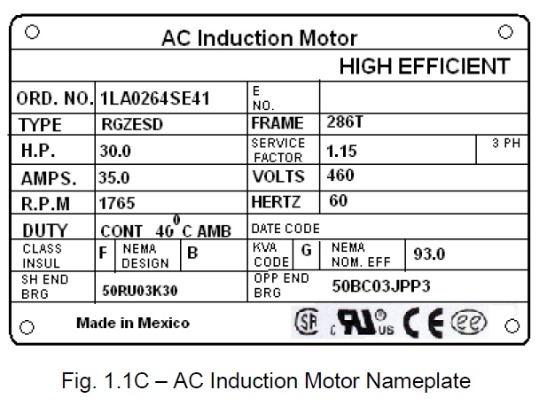**Instructions**

Answer each of the individual questions below.

1. What is the horsepower for this motor? __________
2. How many watts should this motor dissipate? _____
3. What nominal voltage level would you use to connect to this motor? ___________
4. What is the acceptable range of voltage input to this motor? _______ to _______
5. What is the RPM for this motor? ____________
6. If the motor is running at the minimum voltage that you calculated above, it would spin at a slower RPM?
   1. True
   2. False
7. What is a safe and acceptable way to vary the speed of this motor?
8. Decrease the voltage
9. Limit the current
10. Vary the frequency
11. Motor speed can’t be change.
12. A motor’s RPM is determined by what two elements (pick two)?
13. Source voltage
14. Input frequency
15. The number of poles
16. Current draw.

**Instructions**

Answer each of the individual questions below.

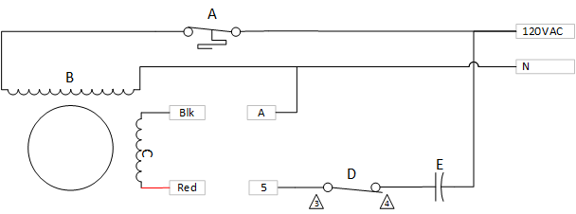

1. Match the components in the above single-phase motor schematic to their components.
   1. ______________ Start Switch
   2. ______________ Capacitor
   3. ______________ Thermal Switch
   4. ______________ Run Windings
   5. ______________ Start Windings
2. If the motor is running CW with Blk wired to 5 and Red wired to A, how should the motor be re-wired to obtain a CCW rotation?
3. Explain why re-wiring this winding causes the motor to rotate in the opposite direction?
   1. AC is flowing in the other direction
   2. The poles of the start windings are reversed
   3. A switch inside the motor is changed
   4. The capacitor is reversed in the circuit
4. This motor can change its rotation while running at full speed.
   1. True
   2. False
5. How does having a capacitor in the circuit cause the motor to rotate in one direction or the other?
   1. There is a phase shift where voltage leads the current
   2. The capacitor changes the direction of current
   3. There is a phase shift where current leads the voltage
   4. The capacitor does not help change direction
6. An AC induction motor has a permanent magnet that creates the magnetic field.
   1. True
   2. False
7. All AC motors can be called squirrel cage motors.
8. True
9. False
10. The motor shown in the schematic above can be started without the capacitor.
11. True
12. False